steel structure

* **with a 10,000 m2 factory and more than 50 skilled personnel equipped with the latest machinery , ,international experience and going through a high standard quality control and product testing.**

**list of some products :**

**1- poultry sheds**

**we provide poultry sheds with any typology and dimensions** 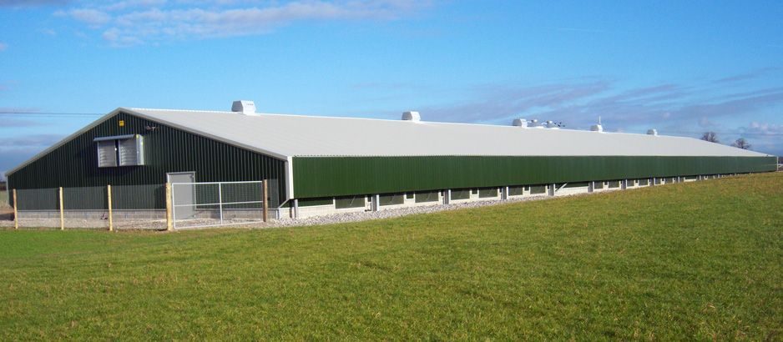

**2-warehouses**

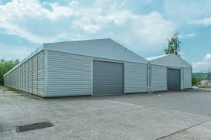

**3-rest houses**

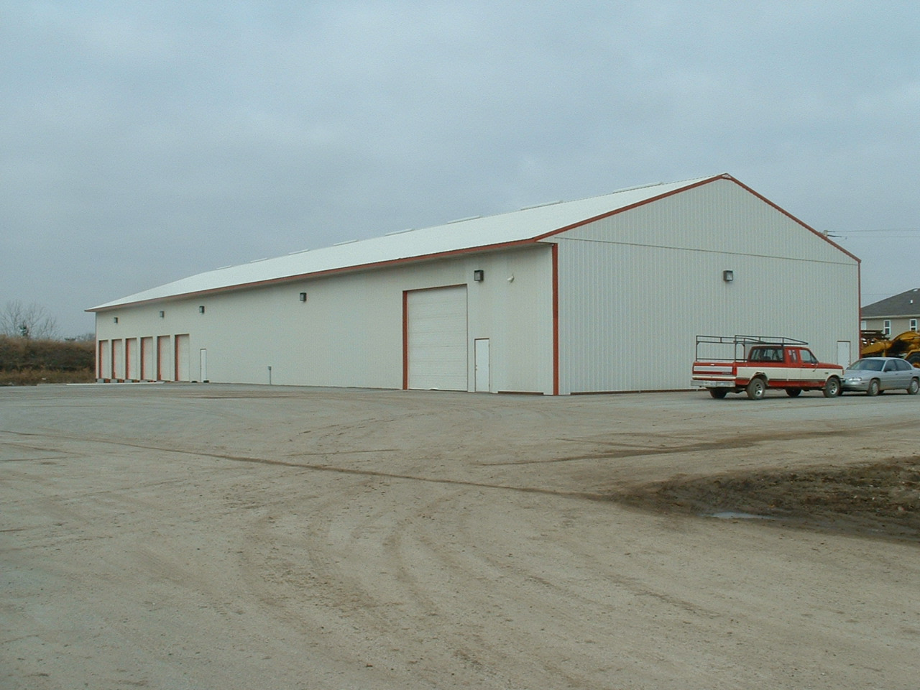

**4- corrugated metal sheets with any color and thickness**

